(Your Name Here) System Enhancements Scheduled for
Friday Morning, Nov. 6th, 2020
New Feature Available to Appraisers: Include Invoice Number on Report Delivery
We want our technology to help better communicate your billing info to your clients. You can optionally add your invoice number to the appraisal delivery screen when sending your completed reports to your clients. When you do this, the invoice number will be tracked and displayed on the order even on successive order deliveries. This will help with faster payment and less confusion.
How to use this feature
Access the system to deliver an order, and move to the Deliver Report tab. Here you will see the new Invoice Number field. This is an optional field. When you enter your invoice here, it will be tracked on the order even if there are multiple order deliveries. Additionally, the invoice number will be tracked on the Appraiser Billing management report for further reconciliation tracking and management.
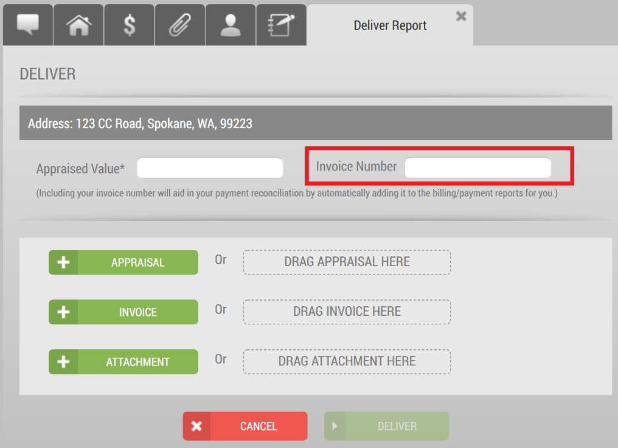

Contact customer service with questions at (Your contact info here).

