**Big Time-Saving Features Coming to (Your Name Here)**  
**Appraisal System Release Info for Friday, Nov. 6th, 2020**

(Your name here) is scheduled to be enhanced with big time features on **Friday morning, November 6th, 2020**. Highlights include an expansion to Verisite Collateral Data to include more AVM data, the ability to create canned messages as well as custom property classifications, additional data to be sent back to Encompass, and more! Read on for complete information.

**Verisite: More Data Available for Comprehensive Property Condition Reports**  
The Verisite Collateral Data report will soon deliver **Confidence Score**, **Value Range: High and Low**, and **Forecast Standard Deviation (FSD)**to provide additional data.  Verisite Collateral Data will now provide everything that a traditional AVM provides at a more competitive rate and within the same appraisal system you use today. We have also added a new **Valuation Summary** section on the first page to assist with providing key property information at a glance.

The areas highlighted here and the red asterisks show the additional data – which means additional value to your clients.

[Click Here for a sample view of the enhanced Collateral Data report in PDF](https://sharperlending.co/wp-content/uploads/2020/10/VerisiteCollateraldata10.30.2020.pdf).

* When combined into the **Verisite Plus report,**you get more value than competing AVM products because we combine current interior and exterior property data with complete AVM data.  Only Verisite delivers current interior and exterior property photos and descriptions PLUS complete AVM data.
* Interested in learning more about Verisite? Contact us for details.

**Create Canned Messages to Make Messaging Simpler**  
Administrators can gain more control over what co-workers and staff are saying in their messages.  Creating reusable, canned messages for common scenarios like status update requests, inspection date inquiries and more can reduce the time spent typing out entire messages.  Canned messages help to maintain consistency across all co-workers and staff when they communicate with appraisers, customer service, and internal staff.

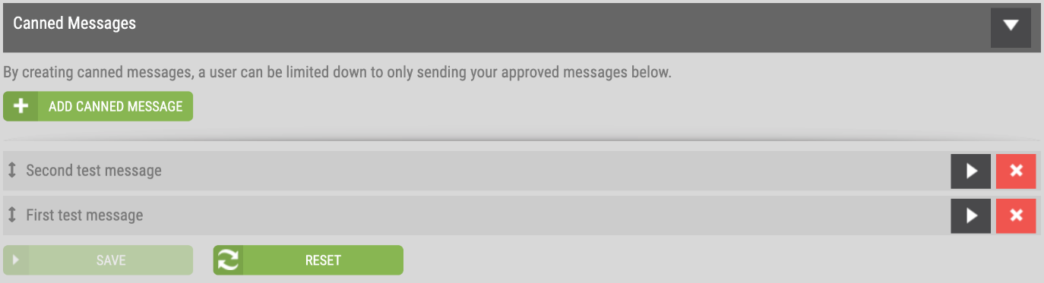

**How to use this feature**

[View the user guide](https://sharperlending.co/wp-content/uploads/2020/11/CreatingCannedMessages.pdf) to set up canned messages for your organization.

**Create Property Classifications for More Accurate Routing and Assignment**  
Just like no two homes are alike, no two properties are alike.  That’s why you need the freedom to create any property classification you want for pinpoint accuracy on your appraisal orders and assignments.  
  
Have a Deed Restriction order that you need to get to an appraiser that specializes in this type of property?  Or maybe an Affordable Housing loan needs the eye of Affordable Housing appraisers, or a horse stable or farm?  In the upcoming release you can simply create a new classification for Deed Restriction, Affordable Housing – or whatever classification you need – then align your appraiser panel accordingly and place your orders with increased accuracy.  And you can set your billing accordingly too.

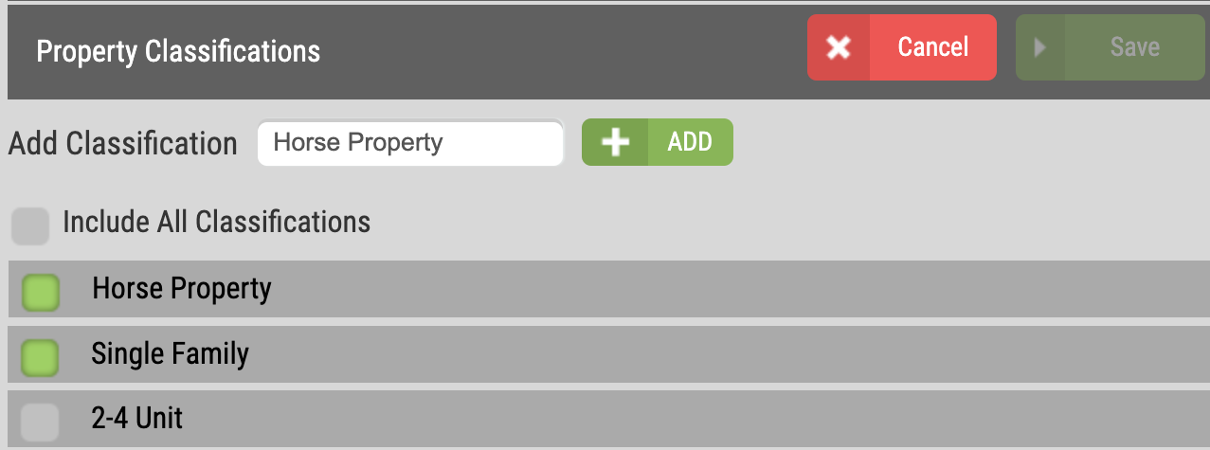

**How to use this feature**

[Click here to view the training guide](https://sharperlending.co/wp-content/uploads/2020/11/AddingNewPropertyClassifications.pdf) on setting up custom property classifications.

**Get More Data in Encompass with Expanded Appraisal Integration**  
Many more data fields will be available to be sent back to Encompass through our portal integration.  See the red highlights below.

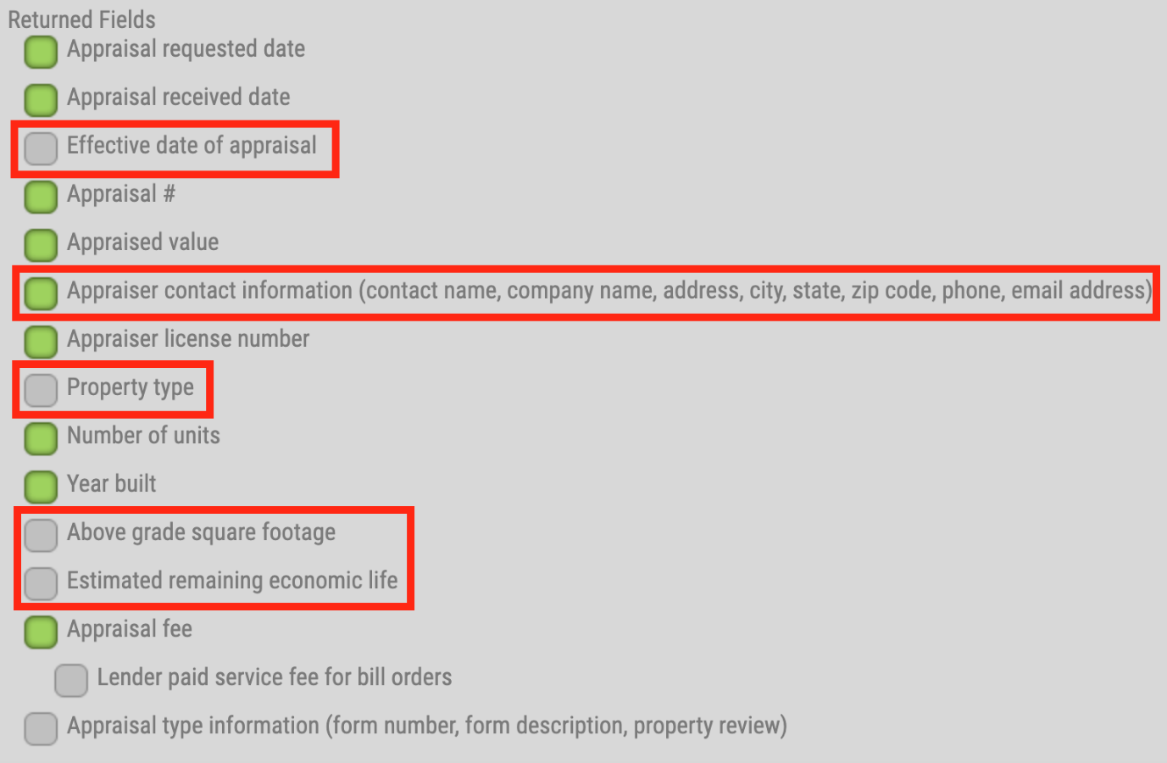

**New and Enhanced Automatic Notifications to Process Orders Faster**The system will start sending out two new automatic email notifications with this release.  These additional notifications will help to ensure that the parties who are responsible for maintaining your process efficiency all know when certain milestones are approaching.  We have also updated the **Unable to Assign** email notification that indicates manual assignment is needed based on the wide variety of settings that may be in place.

* **Order Coming Due Notification Sent to** **Appraisers** – when a residential or commercial order is coming due, the system will automatically send an email reminder to the appraiser within 48 hours of the due date.
* **Borrower Credit Card Payment Info Sent to Managed Users** – if a borrower has not entered their credit card information to pay for the appraisal after 48 hours has passed, the system will send an email notifying all managed users on the order so they can take appropriate action**.**
* **Unable to Assign to Appraiser Notification**– We have updated the verbiage in this notification to apply to more situations that result from the variety of technology settings that may be in place.  The verbiage of the email notification now reads:  
     
  *This order was unable to be automatically assigned to an appraiser on your panel.  A manual appraiser assignment will need to be made in order to move this request forward.  Please contact Customer Service if you need assistance.*

Contact Customer Service with questions at (Your contact information here)