(Your Name Here) Updates Scheduled for
Friday Morning, May 1st, 2020
Release Information for Lender Administrators

We continue to diligently innovate and progress (private label name here) and Verisite to make sure you get the software enhancements you need despite the global COVID-19 pandemic. (Private label name here) is scheduled to be updated with new features and system enhancements listed here which will be available on Friday morning, May 1st, 2020. Read on for complete information.

New Ability to Extract & Download Verisite Photos for Inclusion in Appraisers’ Reports
A key feature that sets Verisite apart from other social distancing appraisal solutions is its built-in fraud prevention feature. Photos that are taken within the Verisite app are geo-located down to approximately 2 feet, are plotted on a map view of the subject property, and soon they will be 3D-validated to ensure the photos are not “pictures-of-a-picture.”

Because of Verisite’s built-in fraud prevention, the photos that populate the Verisite Photo Report are very valuable for appraisers to use as they develop their appraisal reports since they are sure to be of the actual subject property itself. This brings more quality to your appraisal reports, and is why we have made it simple to download the Verisite photos from the report as separate image files.

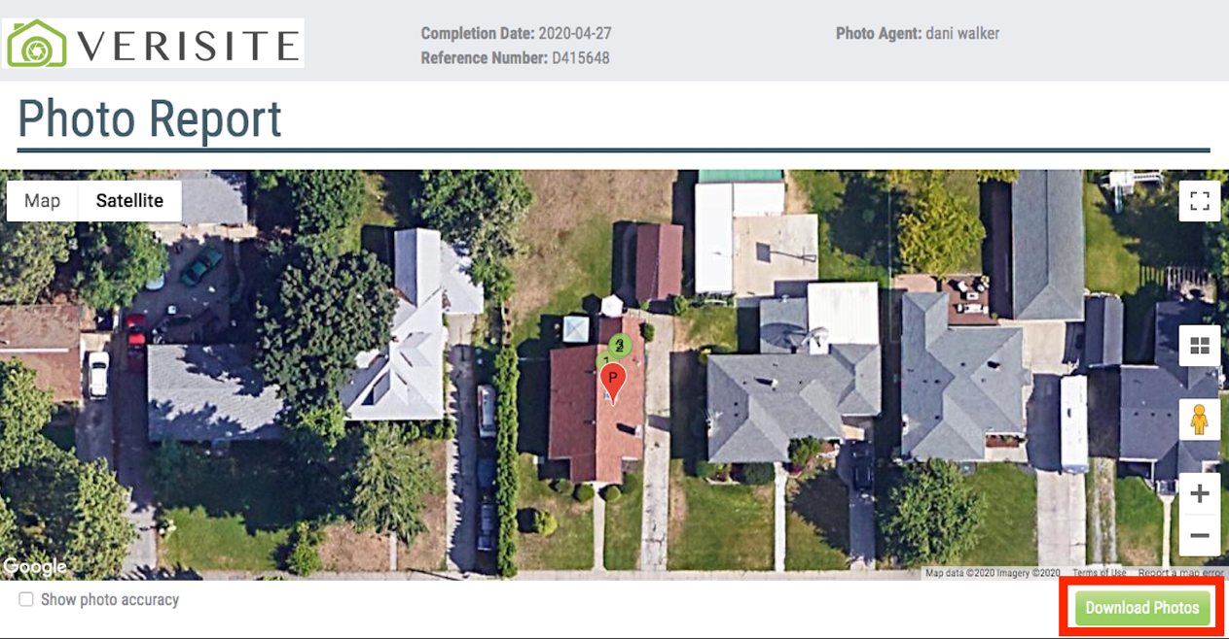

How to use this feature
When the completed Verisite Photo Report is delivered, just below the subject property map at right, there will be a new Download Photos button. Clicking this button will open a dialog box prompting you to select a file location on your local computer where you want ZIP files to be downloaded to. The Verisite photo files will be formatted as JPG files within a ZIP file. Once downloaded, you can go to the location you selected the ZIP file to be saved to, open the ZIP file, and access the geo-located photo files for inclusion in reports.

Send Completed Verisite Orders to Appraisers on New Appraisal Order
During the pandemic, a new appraisal workflow is emerging to keep appraisers and homeowners separate and safe, but to still keep your loan pipelines moving. More and more lenders use Verisite to gather interior property photos from homeowners, and then place an appraisal order to an appraiser that includes the completed Verisite report. This allows the appraiser to have access to the Verisite data and photos to assist them in creating their appraisal report.

This release of (Private Label Name Here) delivers this feature to lenders: the ability to order and receive back a completed Verisite report, and from that request, order a full appraisal with the Verisite report automatically attached to the appraisal order so the appraiser has easy access to it.

How to use this feature
Any lender that is setup to order Verisite will now be able to order a full appraisal from a completed Verisite order. To do this, login and place a Verisite order. Once the Verisite report has been returned, click on the order to open it. The first tab that opens is the Communications tab, and from here at right, you will see a new Order Appraisal button. When you click Order Appraisal, the standard new residential appraisal order screen opens and pre-populates the existing loan and property data. Finish filling out the remaining fields, and when you place the order, the order will be sent to the next qualified appraiser in rotation. When the appraiser accepts, they can open the request into the Communications tab, and view and download the Verisite deliverable to assist with the completion of the appraisal report.

View, Export & Download the Verisite Report Output in PDF
To provide easier viewing and to make the report more portable, we have included the ability for the Verisite report to be viewed and saved in PDF format. PDF files typically are easier to store electronically, and – for those of you that need it – they can be printed in a more readable format.

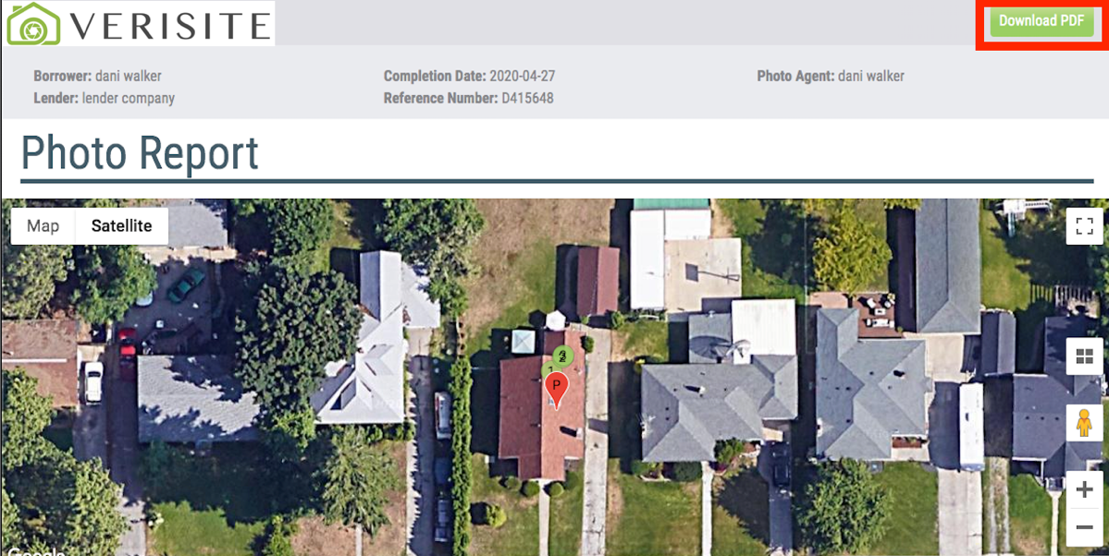

How to use this feature
When the completed Verisite Photo Report is delivered to you, at top right there will be a new Download PDF button. Clicking this button opens the Verisite Photo Report into a PDF version where you can download and save it to your local computer or print it for your loan file records.

New Products Available Based on Fannie, Freddie COVID-19 Updates
As you know, the GSEs released bulletins outlining alternative appraisal inspections due to COVID-19 precautions needed. These bulletins effectively created seven new appraisals products (not different forms but different products on the same forms):

- 1004 Desktop
- 1004C Desktop
- 1004C Exterior-Only Inspection
- 1025 Desktop
- 1025 Exterior-Only Inspection
- 1073 Desktop
- 2090 Desktop

We are making these new products available for order within the system so they can be enabled, ordered and billed in a more specific manner, and submitted to UCDP easier. Therefore, as of this release, these new products will be available in your product lists for users to select and order from appraisers.

- If you use the Fixed Pricing feature, you will likely want to add pricing for these products. To do this, login as an administrator, click the Relationships menu, select the division you want to update, click Edit Settings, expand the Pricing section, and in your Fixed Pricing coverage areas, adjust the pricing for these products. Save your changes, then move on to any other divisions you want to update.
- If you do not want these new products available for your organization or your divisions, login as an administrator, click the Relationships menu, select a division, click Edit Settings, expand the Products section, and de-select the products listed above. Save your changes, then move on to the rest of the divisions you want to update.

Contact us with questions at (Your Contact Info Here)

