(Your name here) Enhancements Scheduled for
Friday Morning, March 27th, 2020
Release Information for Administrators

Despite the health concerns over COVID-19 that are gripping the nation, we are hard at work making sure you still get the software enhancements you need. (Your name here) is scheduled to be updated with new features and system enhancements listed here which will be available on Friday morning, March 27th, 2020. Read on for complete information.

Verisite Photo Agents on Panels can Upload Invoices into System
Verisite photo agents that are on your panels can now do more within the system: they can upload invoices into the system to provide a more complete package of what went on with the transaction. Instead of billing related activity happening outside of the system, you can now benefit from easier, more efficient billing processes and have more complete insight into what happened on Verisite transactions. Additionally, when a Verisite photo agent uploads an invoice, an email notification will be sent out to all lender users on the order, making sure everyone is in the loop.
How to use this feature:
When a Verisite order has been completed and is in a Done status, there will be a new menu option on the Communications tab for Deliver Invoice. When a photo agent clicks the Deliver Invoice button, a new tab will open. The user can click the Invoice button, find and attach their invoice, and click Send to attach the invoice to the completed order. A notification email will be sent to all users on this order, and a new entry will post to the communications log.

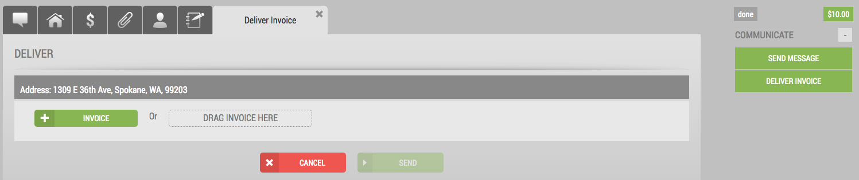

Conditional Acceptance Orders Provide More Info on Appraiser Conditions
When your appraisers accept an order conditionally, the conditions upon which the appraiser is accepting the order will now be included in the notification email sent to all users on the order. With more information in notification emails, your staff can make decisions faster and work more efficiently.
How to use this feature:
There is nothing you need to do – this enhancement is available automatically on any conditionally accepted orders
Appraiser Name Now Included on Declined Order Notifications
In addition to the decline reason and the comments, we are now disclosing the name of the appraiser in the notification when an appraiser chooses to decline an order. This information will only display to Lender Administrators users, and will help with order assignments to provide more information for you up front, at a glance.
How to use this feature:
There is nothing you need to do – this enhancement is available automatically on declined orders.
Lender Admins Auto-Notified Upon 3 Order Assignments
To help you better manage your order assignments, we are enhancing our assignment logic so that, if an order is assigned 3 times, all administrators on the order will receive an automatic email notification. Action doesn’t need to be taken on these emails, but notifying admins when orders are having trouble being accepted can help you better manage your orders earlier in the assignment process.
How to use this feature:
There is nothing you need to do – this enhancement is available automatically upon the third automatic order reassignment.

System-Generated Invoice Now Displays Credit Card Owner Name
We have enhanced the system-generated invoice on all orders paid with a credit card, eCheck, or bank account. The invoice will now include the credit card owner’s name on the invoice to help identify who the card belongs to: the LO or the borrower. The card owner’s name will display in the new Owner Contact column.
How to use this feature:
When you view a system-generated invoice, find the Owner Contact column to see the name of the card holder.

New Option to Customize Your Orders Dashboard
We are providing you with additional data to add to your orders dashboard. You can now add an “Order Creator” column to your dashboard that, when added, shows you the name of the user that placed the order at a glance. The Order Creator option is also available on the Export All button when you want to export your dashboard data into an Excel spreadsheet to use on your local computer.
How to use this feature:
Login to the system and in the Pipeline section at right, click the arrow to configure your orders list. Scroll through the list of Available Fields and find the Order Creator option, then click and drag it over to the Current Fields section. When ready, click Commit. This will add the new column to your order pipeline dashboard.

Admins Can Set Orders to Done to Manage Orders Easier
To help you move orders to a Done status faster, administrators in your office now have the ability to manually set appraisal orders in post-delivery statuses to Done. This can help in situations where disputes may have been requested by LO’s or originators that may not have been warranted or are taking too long – or for other customer service reasons. If you have orders in any post-delivery status such as Corrections Required, Disputing, or Revisions Requested, administrators can now open that order and set it to Done, cancelling all other post-delivery work on the appraisal that may have been requested.
How to use this feature:
Login to the system as a lender administrator user, and open any order that is in one of these statuses: Corrections Required, Disputing, or Revisions Requested. Once the order is open, click the Send Status button at right, and choose Set to Done. This will set the order to Done, send an automatic email notification to lender users and the appraiser, and post an activity onto the communications log.

Contact us with any questions at (your contact phone # and email address here)

