(Name Here) Enhancements Scheduled for
Friday, February 21st, 2020
Release Information for Lender Administrators

Starting Friday morning, February 21st, 2020, a new version of (name here) will be available.

This release includes an overhaul to the appraiser panel management process for you. The enhancements in this release provide ease of use and give you more control over managing your divisions’ panels. Part of this overhaul includes the ability to include Verisite photo agents in a panel that can be rotated through for Verisite orders, and the ability to invite Verisite photo agents to panels. There are many more time-saving enhancements to this release that you can take advantage of.

Read on for complete information.

Enhancements to Managing Divisions’ Appraiser Panels
The main enhancement in this release is an expanded, easier-to-use appraiser panel management screen. This release provides more granularity for lenders to identify what sorts of work appraisers should be able to do on a division’s Manage Appraisers screen.

Now, instead of just one general product type of Residential for panel appraisers, appraisers can be enabled for Commercial appraisals and for Verisite orders in addition to residential appraisals. For example, if you have an appraiser that is setup for residential and commercial and Verisite, but you only want that appraiser to be eligible for Residential orders, you can disable the Commercial and Verisite options by clicking them. That appraiser will no longer be eligible for those product types on the division panel.

One of the key benefits to this update is that you can have a single appraiser panel with different product categories to assign your different orders to. So, if a commercial order is placed, the system will look through that division’s panel to see which appraisers are enabled for Commercial and assign accordingly.

Prior to this, some of you may have had to create different divisions (commercial-only divisions for example) and then add a commercial-specific panel for that division. Of course, this meant switching from screen to screen to manage multiple panels. No more!

Why did we make this change?
- To bring Verisite photo agents into division panels.
- To make the system easier to use by letting lenders make all panel edits on a single division.
- To provide more control over managing your panels with additional appraiser classifications.
- To allow appraisers to opt in to Verisite orders on their appraiser profiles.
- To make way for additional property-related products that come with future industry changes.

How it works
When visiting a division’s Manage Appraisers screen, you can see at a glance what product types appraisers are able to perform per division. Product types are interactive and clickable, allowing for maximum control and panel management.

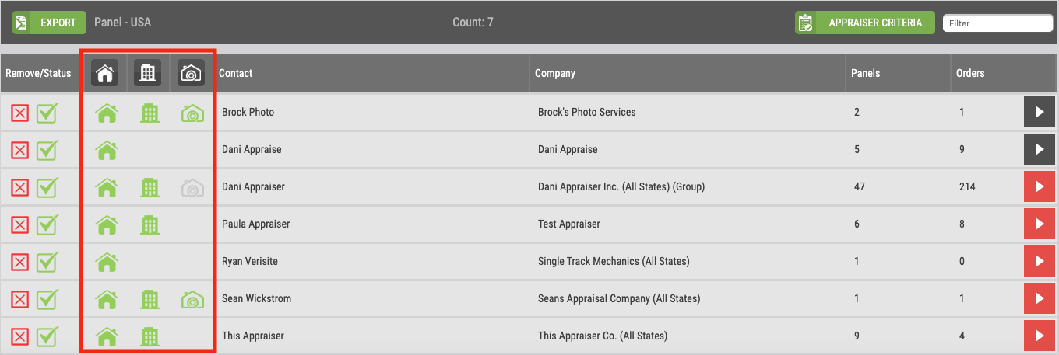
We have also reorganized the columns on this screen to get at information faster.

- Columns have been rearranged for easier editing and management.
- Remove/Status column lets you remove appraisers from this division’s panel (red X) and put appraisers in an On-Hold status.
  - Green check mark indicates appraiser is active (can be assigned orders). Click to toggle.
  - Grayed-out check mark indicates appraiser is inactive (cannot be assigned orders). Click to toggle.
- New product type columns and icons identify types of work appraisers can do for this division at a glance.
  - House icon – indicates appraiser can perform residential appraisal work.
  - Building icon – indicates appraiser can perform commercial appraisal work.
  - Camera icon – indicates appraiser can perform Verisite mobile property inspection work.
  - Icons can be clicked to enable/disable specific appraisers for that type of appraisal product. Green icon indicates appraiser is enabled for this appraisal product type; gray icon indicates appraiser is disabled for this appraisal product type; no icon displayed indicates the appraiser’s individual profile is not setup to do this kind of work. Appraisers with gray icon/no icon displayed for a product type means they will not be assigned any orders of this product type.
- The remaining columns display appraiser first and last name, company name, # of panels the appraiser is on, and # of orders the appraiser has been assigned.
- Click the arrow button at right for in-depth appraiser profile detail.

Appraisers can Mark Themselves as Verisite Photo Agents, be Included in Panel Assignment
Our Verisite mobile property inspection tools are catching fire in the appraisal world. This is likely due to GSE appraisal modernization initiatives and mobile technology trends.

Many of you have requested the ability to manage a panel of Verisite photo agents like you manage an appraiser panel, and we listened. With the panel management overhaul in this release, Verisite photo agents can be included in your appraiser panel. When a Verisite order is placed, the tried-and-true appraiser selection logic that the system uses is now applied to Verisite orders, and the next qualified photo agent in rotation will be assigned the order.

How to include Verisite photo agents in your panel:
- First off, photo agents should visit AppraisalFirewall.com and create an appraiser account – even if the person acting as a photo agent is not a licensed appraiser. (Existing appraisers can login to their appraiser account, go to their Settings gear icon, expand Appraisal Types, and check the Verisite Photo Agent checkbox.)
- After they fill out their Profile information, they are prompted to fill out their Settings, which takes them to the Appraisal Types section. Verisite photo agents should be sure to check the Verisite Photo Agent checkbox as they fill out their Settings.
- Once they are done and Save their changes, lenders can place Verisite orders in a rotation fashion, and the next qualified photo agent in rotation will be assigned the order.

Want to learn more about Verisite and how it can help your valuation process? Contact us for more information and a demo at (your contact info here).

Invite Appraiser Screen Updated with New Product Types: Residential, Commercial, Verisite
As a part of the panel management enhancements, when you visit a division’s Manage Appraisers screen and invite an appraiser to join your panel, you can now select product types. This will help align your need with the kind of work the appraiser does.

How to use this feature
Login and click the Relationships menu, select a division from list, expand the division, and click Manage Appraisers. On the Appraisers screen, click the Invite Appraiser button. You will see a new section here called Please select the type of work this user can perform for you, and 3 checkboxes: Residential, Commercial, and Verisite Photo Agent. Choose what types of orders this appraiser should be eligible for on your panel, enter their email address, and click the green arrow to send the invite. Once the appraiser accepts the invite, they will be added to this division’s panel as an appraiser that’s eligible for these types of orders from this division. Note that if the type of work requested here does not correspond to the type of work the appraiser can do, they will not be eligible for those product types when they accept the invitation.

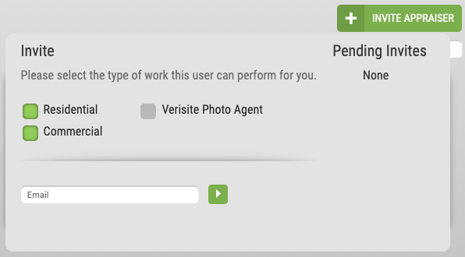

Other Enhancements Include…

Manual Assignment Enhancements Provide More Efficiency for Ordering
Many of you use the Manual Assignment feature that captures an appraisal order but places it in a Requested status until an Administrator manually assigns the order to an appraiser. We have enhanced this feature in a hybrid manner so that orders can be placed into a Requested status to hold it, and when ready, any user can initiate the automatic appraiser panel assignment process. This is an optional feature that can be enabled as needed.

This allows manually assigned orders to still take advantage of automated assignment without bothering administrators: LOs can capture the order data, place orders in a Requested status, and when the timing is right, initiate the order to be assigned to the next qualified appraiser via their appraiser panel automatically. This is especially helpful for new construction lending.

How to use this feature
Login as an admin, click the Relationships button, and on the Divisions tab, select the Division you want to enable, then click the arrow at right to view division details. Click Edit Settings, then click the General Settings option. Find the Assigning Orders section, then locate the Manual Rotation setting. When you check Manual Rotation, a new sub-checkbox is available called Allow Managed Users to Trigger Assignment. Check this checkbox to enable this feature, and save changes.

When this checkbox is checked, orders that are placed but not yet assigned to an appraiser will have a new option on the Parties tab called Trigger Assignment. The Trigger Assignment button is available to any user that has access to this order. When a user clicks Trigger Assignment, the appraisal order will go through the automated appraiser panel assignment process to assign an appraiser. This process maintains the double-blind ordering process, so managed users can initiate the ordering process without knowing which appraiser gets the order.

New “Federally Related Transaction” Indicator Available on Residential Orders
We realize that regulatory compliance is a part of life. Recently, the OCC sent a bulletin requiring that any OCC-supervised bank that 1) orders an appraisal on a loan that is a “Federally Related Transaction” and 2) uses an AMC to perform the appraisal must indicate that the order is a Federally Related Transaction (FRT). This is why you will see a new checkbox on new residential orders called Federally Related Transaction. Questions about using this checkbox should be directed to your compliance officer or related department. Click here to review the OCC bulletin.

How to use this feature:
Login and place a new Residential order. On the order screen, there will be a new Federally Related Transaction checkbox. This checkbox should be used if the organization qualifies as an OCC-supervised bank, and the appraisal is a qualifying order. To track and manage FRT orders, lender Administrator users can access the Reporting menu, and locate the new Federally Related Transaction checkbox. Check this checkbox to include FRT data in management reports.

Contact us with any questions about this release at (contact info here).

